School planning example-Substance Misuse (Primary Schools)

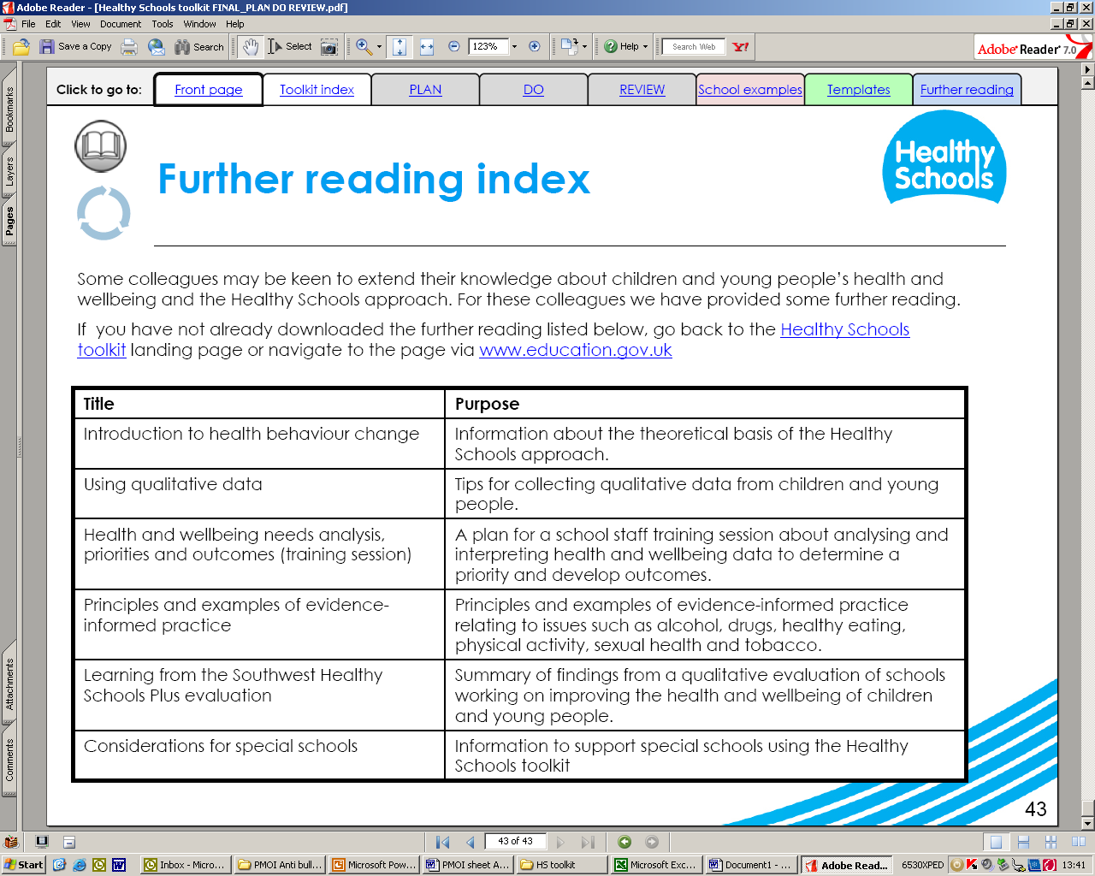
Leicestershire Healthy Schools
Priority: Substance Misuse (Primary Schools)
Priority:
There is an increase in the number of children achieving specified outcomes in relation to Drug, alcohol and tobacco education/PSHE
Priority:
An increase in the number of children from x% to x% , who report that they find it easy to talk to their parents about drugs and alcohol, whilst parents say they feel more informed and confident to discuss this issue.

Priority:
To increase the number of children identified as being affected by drug and alcohol issues and appropriately supported and/or referred
- There Drug, alcohol and tobacco education policy and practice has been reviewed with the involvement of the whole school community. (p)
- There is an increase in the amount of time dedicated to PSHE. (p)
- Assessment in PSHE is recorded and reported. (p)
- All teachers have received PSHE training in relation to their needs and to support the scheme of work. (p)
- The reviewed PSHE programme has been trialled and pupil feedback has been positive. (I)
- Teacher assessments show and increase year on year of children fully achieving outcomes from PSHE programme (I)
- Initiatives to support and increase in parental knowledge and confidence in discussing drugs, alc and tobacco are in place. (p)
- Targeted families are taking part in the ‘How to drug proof your kids’ programme. (p)
- Parents report feeling more confident in talking to their children about drugs and alcohol. (I)
- Targeted families are taking part in the Family SEAL programme.(p)
- An increase from X% to X% amongst targeted children reporting they feel happier in school .(I)
- An increase from x% to x% for appropriate referrals to support agencies. (I)
- Increase in pupils reporting they know where to get support. (I)
- Key staff have received appropriate training to support children experiencing family/carer related substance misuse. (p)
- Confidential advice available to all pupils. (p)

Milestones
Outcomes
I= Impact
P=Process

