Dear School,
Leicestershire County Council is supporting a new campaign called VEGPOWER. We would like to invite your school get involved in this campaign. VEGPOWER is a national campaign that can contribute towards improving the health and well-being of children across Leicestershire by supporting:
- Leicestershire County Council’s Sustainable Food Plan
- The Leicestershire Healthy Schools Programme
We are making a VEGPOWER pack available for every school in Leicestershire – it is a high profile, imaginative campaign that aims to inspire everyone to eat more veg!
It is supported across all of the Leicestershire County Council Departments (including Leicestershire Traded Services – a provider of school lunches across the County) as well as through the Soil Association’s Food for Life programme which works with a number of schools in Leicestershire.
To support VEGPOWER and as a valued partner we would like you to use the enclosed pack to encourage the children attending your school
- to eat more veg
- to take the message home with them
- to get involved with the campaign through social media and school lessons or homework
You can access extra resources directly through the Leicestershire Healthy Schools website or the VEGPOWER website.
We will be providing updates for the campaign at our Healthy Schools Network Events and on the Leicestershire Healthy Schools website.
We are hoping to provide enough VEGPOWER packs for every child in your school. If you wish to take advantage of this FREE offer, you will need to arrange for the postage/delivery to your school.
Alternatively, packs can be collected from County Hall, Leicestershire County Council – For more information on the Campaign or to register your interest in obtaining more VEGPOWER packs please contact healthyschools@leics.gov.uk
We have enclosed an example pack for your information and we are looking forward to work in partnership using the VEGPOWER campaign to convince children to eat more veg!
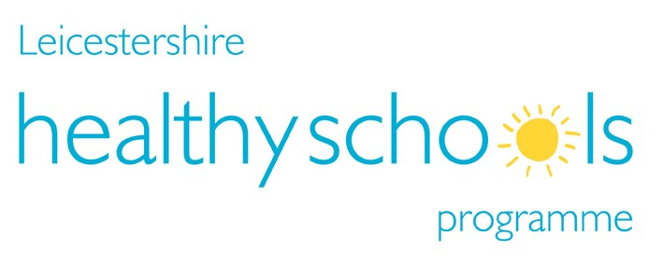

Background
Veg Power is an independent not-for-profit brand manager for vegetables which uses advertising and marketing techniques to inspire everyone to eat more veg. Veg Power launched in September 2018 after securing core funding from a mix of retailers, growers, food manufacturers, government, NGOs, and individuals (vegpower.org.uk).

The Campaign
On 25 January we launched a massive national advertising campaign on ITV. The ad itself encourages kids to have fun with veg whilst focussing on the important matter of eating them. It will feature a wide range of real veg (see the website for a link to the advert).
To support the TV campaign, we have nine different supermarkets chains across the UK helping to make veggies more exciting and affordable. We are expecting a high level of media coverage, including support from kid’s favourites First News and Beano. We’ll have strong support from ITV shows such as The Voice, This Morning and kid’s favourite Scrambled!, as well as social media buzz with many celebrities, chefs and sports stars encouraging parents, carers and kids to get involved.

Reward Charts
Finally, we want to help parents and carers to engage their kids with the campaign at home. So we have created a fun rewards chart which encourages kids to try new vegetables. These packs contain the A3 wall chart and a pack of stickers to track their progress on their chart. Each pack also comes with a fun sheet of food safe stickers with googly eyes and monster mouths which kids to use to play with real veg.
The packs are intended for KS2 age groups, and will neatly slip into school bags.
Yours sincerely,
Healthy Schools Team (Public Health Dept. Leicestershire County Council)

