School planning example- Promoting a Healthy Weight

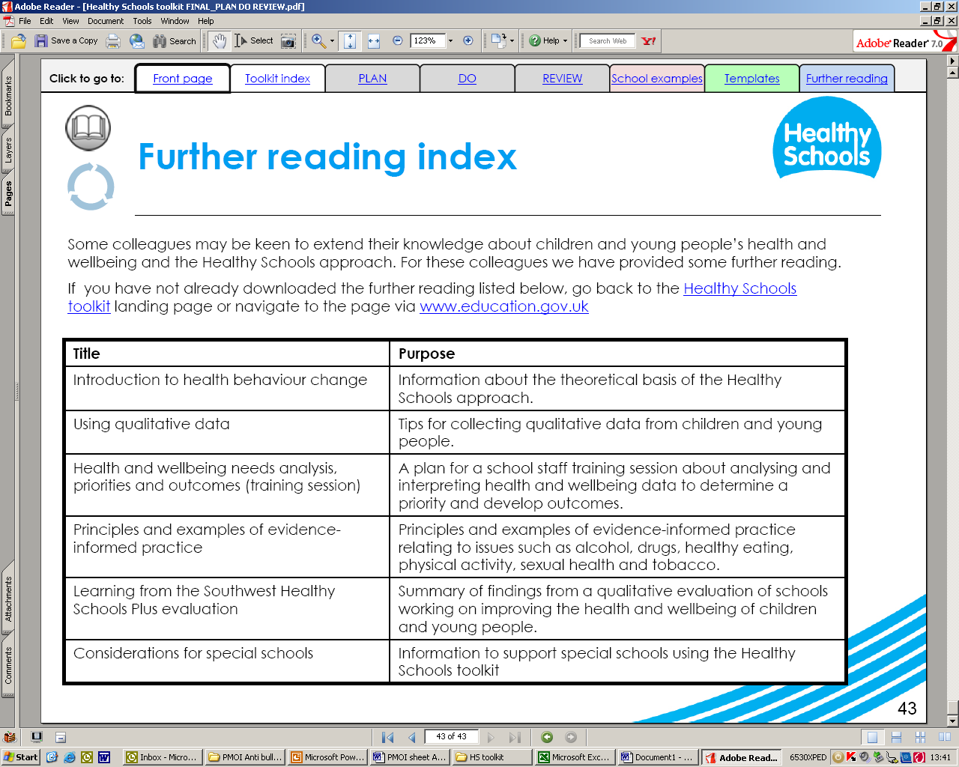
Leicestershire Healthy Schools
Priority: To promote a healthy weight
Priority: To increase the number of C/YP participating in xx hours and more physical activity from XX to XX

Priority: To increase the number of C/YP who report that they enjoyed participating in physical activity from XX to XX.

Priority - - Increase in participation in physical activity of children /YP who do not currently participate from xx to xx

- Systems in place to identify children’s/young people’s participation in PA (P)
- Successful working with cluster schools with increased facilities and range of equipment (P)
- School travel plan supports increased range of activities offered both within school and extra curriculum activities (P)
- ‘StarWalker scheme in place (P)
- An increase in the number of staff who understand that active learning contributes to PA (P)
- Increase in the number of staff delivering active lessons contributing to PA across the curriculum (P)
- Increase in the number of staff using drama, singing and active breaks in lesson activities (P)
- An Increase in provision of exercise DVD/games for local community in school library (P)
- An increase in access to bike facilities (e.g. bike hire, bike racks) (P)
- An increase in the number of opportunities for cycle training (P)
- Development of safe cycle storage capacity (P)
- An Increase in the number of children/YP cycling to school from X to XX (I)
- An Increased in the number of children/YP walking to school from X to XX (I)
- An increase in the range of PE curriculum sports available (P)
- Needs led extended training programme for all staff delivering physical activity in the locality (P)
- An increase in the number of children participating in physical activity within local community groups
- An Improvement in Children and YP’s Physical Development through the implementation of the Physical Literacy toolkit (P/I)
- An increase from xx to xx of children/YP who report enjoying PA after the first year (I)
- An increase from xx to xx of children accessing extra curricular activities (I)
- An increase in identified children accessing extra curricular activities (I)
- An increase in the number of young carers with support plans (P)
- An increase in free transport from school to home for targeted groups (P)
- An increased number of free/funded places for target groups (P)
- Raised awareness of support agencies to families of target groups (P)
- Number of trained identified members of staff who provides support to targeted groups (individuals/groups) increased from X to XX (P)
- Understanding of what is a healthy weight and teaching links between healthy lifestyle and emotional health e.g. body image (P)
P – Process
I – Impact
Milestones
Outcomes

